**Culture Development Strategy**

**Introduction**

Birmingham Metropolitan College (BMet) is a college that is firmly focused on raising aspirations and improving life chances for young people and adults in Birmingham and its borders.

Underpinning BMet 2030 is an ambitious strategy establishing BMet as an FE anchor institution in and for Birmingham. We intend to continue to accelerate our improvement strategy so that high quality learning is delivered at every BMet college site with provision that equips local people with skills and knowledge to take them further in their careers.

This means BMet needs to be a good employer delivering on its civic responsibilities, including being part of Birmingham’s aim to be an anti-racist city, and one of our strategic priorities is to be an inspiring place to work. Fundamental to this is our work to continuously develop our organisational culture.

Culture is who we are. Our purpose is to ‘inspire futures and realise dreams’ and is about our shared values, how we express ourselves, our behaviours, and our practices. It is what defines us and how we are changing. Within this are inter-woven threads: equity, diversity and inclusion; wellbeing and engagement; and sustainability. Our ultimate aim is for BMet to be a confident, highly effective learning organisation which operates in the best interests of our people and planet.

Our Culture Development Strategy incorporates our work to drive an inclusive culture at BMet, a culture which supports the health and wellbeing of all, as well as our aim to pioneer environmental responsibility. It is supported by the the High Performing Team (HPT) model which encapsulates behaviours which align with our cultural aspirations and so forms the basis of ongoing development at individual, team and overall organisational level.

Diagram: Behaviours aligned to High Performing Teams

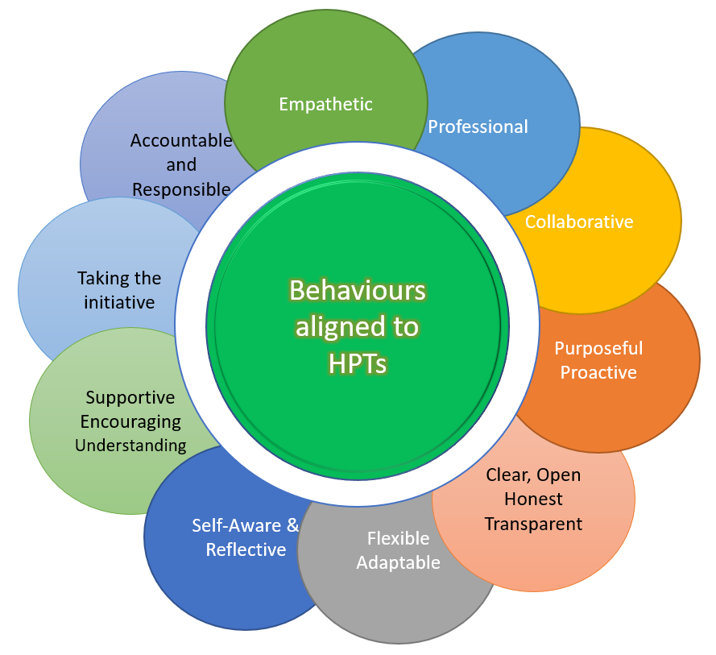

**We will use this strategy and underpinning action plan to:**

1. Drive forward our Diversity and Inclusion priorities, meet our statutory obligations under the Equality Act 2010 and Public Sector Equality Duty 2011, enhance our work with external bodies and support our aim to be an inspiring place to work and to provide excellent learning opportunities for Birmingham and the city region.
2. Drive Wellbeing and Engagement for our people
3. Drive Environmental Sustainability; understanding that averting the catastrophe of non-reversible climate change is a crucial issue of our time

Our Resourcing Strategy and our Professional Development Strategy alongside our infrastructure development will support us achieve our objectives.

Diagram: The 3 pillars of BMet’s Culture Development Strategy

# 

# Context

We recognise the challenges of social and economic inclusion in our communities particularly for those who may face barriers because of multiple aspects of their identity, including age, race, gender, disability and health, socio-economic background, pregnancy and maternity, religion and belief, sexual orientation and family and relationship status.

We recognise that the climate crisis is not just an environmental crisis. It is an inequality crisis. We understand that whilst the climate crisis affects the entire planet, we are not all affected equally and that some communities are impacted harder than others.

As a large education provider and employer in the region we are well placed to be part of, and to progress, change; to positively impact and inspire those communities with which we work and learn. We are in a position to develop a cultural identity founded on environmental responsibility and innovation.

**Developing our strategy for 2024-2028**

In considering our focus for our 2024-2028 strategy BMet stakeholders were consulted through a range of activities including a student and parent/carer/guardian survey and employee engagement workshops in the autumn and spring terms of 2023-2024. Participants were asked what is important to them and the areas of action we should concentrate on. Our consultations have informed our strategy alongside:

1. College Strategic Plan
2. Colleges West Midlands Race Equality, Birmingham Race Impact Group (BRIG) City FE College Commitments, Student Commission for Racial Justice (SCRJ) plans
3. BMet’s Quality Improvement Plan
4. Data intelligence including student, staff, apprentice participation, satisfaction and progress
5. Student, staff, parent and employer consultation
6. BMet’s Sustainability policy

Headlines from staff, student and parent/carer/guardian feedback. What’s important to people?

* Mental health – improved awareness and support
* A collaborative approach to anti-racism
* Inclusive spaces – accessible, flexible, supporting a range of requirements
* Disability, health and neurodiversity
* Address inconsistencies in staff and student experiences
* Develop cultural awareness/understanding
* LGBTQ+ inclusion

**Diversity and Inclusion**

|  |  |  |  |  |
| --- | --- | --- | --- | --- |
| Objective -**Improve engagement and success of our students and apprentices; increase participation, progress and achievement of those currently underrepresented or underperforming in BMet’s student community.** | | | | |
|  | We will do this by the following actions | Who will lead this | We know we have done this when | We will have  achieved this by |
| 1 | Reducing our college’s achievement gap between all ethnic groups* to less than 5% by 2025 (*where student numbers are greater than 100); through:   1. Teachers using starting points to personalise learning 2. Employing a range of attendance strategies 3. Fostering high expectations and aspirations for all students especially those who are ‘at risk’ 4. Ensuring all staff are culturally literate and use a trauma informed approach; incorporating cultural awareness training/changing perceptions initiative for staff and students (informed by student voice; and a programme of cultural diversity events and celebrations. 5. Our agency and hourly paid staff are up to speed with college approach | Deputy Principal and VPs | Our college’s achievement gap between all ethnic groups* is reduced to less than 5% (*where student numbers are greater than 100)  Learners and staff have increased awareness and appreciation of different cultures.  A programme of cultural diversity events and celebrations are aligned to the curriculum delivery. | Nov 2025 |
| 2 | Working to targets for curriculum areas to increase participation where participation is low; implementing individual action plans supporting each area of work | VPs and Directors | 1. 45% of apprentices are BAME (60% from a Birmingham postcode) 2. 15% of apprentices have a disability, difficulty or health condition and disabled apprentices achieve in line with peers 3. 8% of construction students are female 4. 20% of engineering students are female 5. 24% of digital technology students are female 6. 20% of health & social care students are male 7. 10% of Early Years students are male 8. 25% of Travel and Tourism are male 9. 40% of Uniformed Services students are female | Apr 2028 |
| 3 | Becoming a College of Sanctuary   1. Researching and understanding the College of Sanctuary programme 2. Evaluating current policies, practices, and procedures to identify areas where we can enhance support and inclusion for refugees and asylum seekers. E.g. through admissions processes, student support services, curriculum development, or community engagement. 3. Engaging with the local refugee community: to build connections, establish partnerships, and gain insights to inform an action plan | Director of Student Experience | BMet is a welcoming and supportive environment for refugees and asylum seekers.  We build a wider College of Sanctuary movement. | Dec 2025 |
| 4 | Building-in consistency in our students’ and apprentices’ personal development beyond their qualification. Delivered through:   1. a comprehensive personal development programme for all learners (including improving confidence and behaviours, promoting physical and mental health and wellbeing (including financial health/cost of living) and increasing employer prominence in the learning environment 2. a curriculum that provides learners with the opportunities to learn to become confident, resilient, active citizens; knowing how to stay safe; and supported into next steps 3. taking a cross college approach to LGBTQ+ inclusion, race equality and sexual harassment | VPs and Directors | Our students have wider skills developed which prepare them for a diverse society and workplace.  They are equipped with skills and knowledge for living and working in modern day Britain. | Mar 2028 |
| Objective – Our workforce more closely reflects our student population and our local community | | | | |
|  | We will do this by | Who will lead this | We know we have done this when | We will have  achieved this by |
| 5 | Improving the ethnic diversity of our workforce.   1. our resourcing strategy including targeted reach to talent, inclusive recruitment process and opportunities to progress for existing staff through a Future Leaders Programme 2. our professional development strategy | Director of Human Resources and Development | 40% of our leaders and managers are Black, Asian or from a minority ethnic background  50% of workforce are BAME | Mar 2028 |
| 6 | Improving the diversity of our governors through:   1. developing the BMet Ambassador scheme enabling more people to explore being governors over an initial 12- 24 period. 2. reviewing and developing a Governor recruitment aspirations and associated strategy. | Company Secretary | Our governors will reflect the profile of our local community | Sep 2027 |
| Objective - We will ensure we promote inclusion for our disabled stakeholders | | | | |
|  | We will do this by | Who will lead this | We know we have done this when | We will have  achieved this by |
|  | Achieving Disability Leaders Status through:   1. Our estates strategy to improve accessibility 2. BMet’s resourcing strategy 3. Co-designing and delivering Birmingham’s Disability Festival 4. Launching Accessible Apprenticeships and Supported Internships 5. Publishing our Disability Pay Gap 6. Developing an inclusive sports centre at Sutton Coldfield College 7. Equipping staff with BSL to improve accessibility for D/deaf applicants/students 8. Improving Neurodiversity awareness and skills for all staff and further developing TLA resources for disability inclusion 9. Offering further enrichment for Inclusive Support/Send students | Diversity and Inclusion Manager | We achieve Disability Leader status. We have led by example with:   1. improved facilities and accessibility for students/staff and visitors with disabilities. 2. 20% of our staff have shared that they have a disability, health condition or are neurodivergent and are supported to progress 3. Birmingham’s first disability festival 4. the launch of Accessible Apprenticeships and Supported Internships 5. our disability pay gap report is published on our website 6. the opening of our inclusive sports centre 7. we have trained 5 staff with basic BSL level 1 and understand routes for communication support 8. we understand disability and neurodiversity and meet student and staff needs 9. our SEND students have an enriching time at college and learn skills beyond their qualification | Dec 2024 |
| Objective -We will strengthen stakeholder engagement and enhance our social value | | | | |
| 8 | Recruiting and developing a team of changemakers working across EDI, Wellbeing and Engagement and Environmental Sustainability threads | Diversity and Inclusion Manager | Team of changemakers driving D&I activities | Jan 2025 |
| 9 | Strengthening/developing further employer and community partnerships to support regional business community including:   1. Developing a diversity and inclusion toolkit and training for employer engagement teams to use with local employers, particularly SMEs; 2. Developing, piloting and evaluating the tools with employers; toolkit available for rollout 3. Exploring kite mark to recognise inclusive recruitment practice 4. Employers co-produce/design curriculum offer 5. Developing community led programmes to work in partnership with community leaders and influencers to develop training that supports adults to retrain and re-skill | VP for External Engagement | A toolkit is being used by employer engagement teams and feedback received from stakeholders informs future iterations.  Employers are inclusive in their recruitment and support of young people and adults.  Our curriculum business plans will outline what engagement has happened with employers and through governance reporting on BMet Skills contribution to the West Midlands region.  Annual review of community provision and adult provision through Adult Skills strategy. | Mar 2025  Mar 2028  Dec 2024  Apr 2025 |
| 10 | We will contribute to NEET reduction through:   1. Working collaboratively with the Colleges West Midlands Group to improve transition into and out of college 2. Developing an effective Risk of NEET indicator (RONI) tool as an early warning system 3. Developing a way to provide re-engagement activities | VP for Matthew Boulton | We are employing good practice in NEET strategy and have contributed to the region’s reduction in NEETs | Jul 2025 |

W**ellbeing and Engagement**

|  |  |  |  |
| --- | --- | --- | --- |
| Objective - Strengthen mental health awareness, understanding and support | | | |
| We will do this by | Who will lead this | We know we have done this when | We will have  achieved this by | |
| 1. Ensuring all staff have understanding and skills in mental health:  * Training and development activities for line managers * Training and development activities for all staff | Director of People and Culture  VP for Quality Teaching and Learning | Managers and all staff have understanding of mental health and are skilled at supporting themselves and others.  Reduced mental health related sickness absence.  Improvement in score for ‘leaders and managers are considerate of my wellbeing’ in full Staff Survey | Jul 2026 | |
| 1. Further developing mechanisms and spaces for inclusion and support  * Implementing an enhanced Employee Assistance Programme * Raising profile of wellbeing offer through staff networks, MHFA, changemakers, line managers * Protecting time and space to talk, rest and ‘play’ at individual, team and wider organisation level | Director of People and Culture  SLT | Employee Assistance Programme with enhanced offer implemented.  Reduced mental health related sickness absence.  Improvement in score for ‘leaders and managers are considerate of my wellbeing’ in full Staff Survey | Dec 2024  July 2025  Sep 2025 | |
| Objective - Address inconsistencies in staff experiences | | | |
| We will do this by | Who will lead this | We know we have done this when | We will have  achieved this by | |
| 1. Exploring areas of concern identified from data available | Director of People and Culture  SLT | Findings inform targeted areas of action | Apr 2025 | |
| 1. Developing managers in key people conversations e.g. return to work discussions, agile working, effectively exercising discretion and judgement within business need 2. Continuing with leadership development supported by Action Learning Sets | Director of People and Culture  SLT | Timely, effective, consistent and balanced approach to people conversations  Reduced sickness absence | Jul 2025 | |
| **Objective -** **Improve staff engagement** | | | |
| We will do this by | Who will lead this | We know we have done this when | We will have  achieved this by | |
| * Extending gestures of recognition * Attributing ideas/suggestions to individuals * Focusing on praise * Understanding employees’ starting points AND what they bring * Further developing story-telling * Identifying opportunities to build a sense of community | Director of People and Culture  SLT | Improved overall rating in staff survey | Sep 2025 | |

**Environmental Sustainability – a green thread**

|  |  |  |  |
| --- | --- | --- | --- |
| Objective - Build knowledge and awareness of environmental sustainability | | | |
| We will do this by | Who will lead this | We know we have done this when | We will have  achieved this by | |
| 1. Developing staff  * All staff encouraged to complete online Climate Change course * Staff CPD sessions designed with sustainability in mind and incorporate green thread | VP for Quality Teaching and Learning | Understanding influences behaviour change. All events, activities, projects incorporate sustainable practice.  Teaching staff incorporate sustainability and green skills into curriculum for all courses. | Jul 2025 | |
| 1. Sharing ideas and practice through e.g.  * Sway collation of ideas * A Behaviours Booklet/guide on green behaviours * Events to share learnings, changes and impact (tea and talk) | Green Changemakers | Staff understand behaviours, working and learning practices that reduce our carbon footprint and implement changes in their area of influence. | Jul 2025 | |
| **Objective - We will strengthen stakeholder engagement and enhance our social value** | | | |
| We will do this by | Who will lead this | We know we have done this when | We will have  achieved this by | |
| 1. Developing a team of Green Changemakers.  * Engage with new Green Changemaker courses delivered through Fircroft  1. Establish climate action network with local colleges and universities | Diversity and Inclusion Manager  Director of Estates | We have a growing group of BMet Changemakers driving change within and beyond the organisation | Jul 2025  Jul 2025 | |
| 1. Implementation of projects (e.g. BMet joins the Climate Emergency Campaign, Race to Zero, Increase the Green, travel) 2. Engage green volunteering activity through offering employees time out for civic volunteering. | Director of Estates  Company Secretary | Projects support work towards BMet’s Sustainability and Net Zero Targets for 2045  Our Corporate Social Responsibility policy incorporates employee and civic engagement. | 2028 | |

**How we will monitor progress**

We will continuously evaluate and review the strategy's outcomes and impact through a range of mechanisms including our data dashboards, quality review and SLT meetings. We will use our D&I Annual Report to publish our progress towards meeting our objectives yearly. We will communicate and celebrate our progress and successes through our weekly and termly bulletins to staff, parents/carers and students.